NDI OptoTrak

Prerequisites

NDI Portable CMM (ToolTray v.2.19.2.856 at the time of this writing) and Perceptron ScanWorks (v.5.60.017 at the time of this writing) must be installed and running before SpatialAnalyzer will connect to the instrument.

Starting the Interface

- Set up your network address per the OPTOTRAK_PROseries User Guide:
Ethernet Connection Setup
The Ethernet network connection between the System Controller and host computer must be dedicated and closed. The System Controller cannot be connected to the host computer as part of a larger local or wide area network.
NDI-Supplied Host Computer
If the host computer is meant to be on a network, it will have two preconfigured Ethernet ports. One port is for connecting to local or wide area networks. The other port, which will be labelled, is the dedicated line for communication between the System Controller and host computer.
User-Supplied Host Computer
The network connection between the System Controller and host computer must be closed to other network traffic. Set your host computer to a static IP address of 192.168.101.100, and a Subnet mask of 255.255.255.0. Refer to your operating system documentation for more information about configuring your computer’s TCP/IP settings.
- Ensure NDI ToolTray and Perceptron ScanWorks are running and instrument is operating correctly per OEM guidelines.
- In SA, select Instrument > Add and choose the NDI OptoTrak from the Instrument List.
- From the Windows Task Bar, right click on the NDI ToolTray icon…
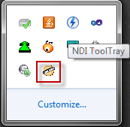
You will get the ToolTray pop-up menu, where you can select the mode in which the hardware will start…
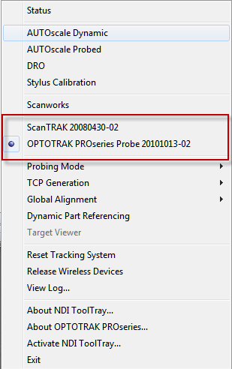
Here, the system is in Probe mode. Just select “ScanTRAK…” to start up in scanning mode.
- Run the instrument interface using Instrument > Run Interface Module and Connect or ()

Instrument Interface Overview

Probing Mode
If you have started the interface with the OptoTrak probe selected as above, you will see the following window upon starting the interface.
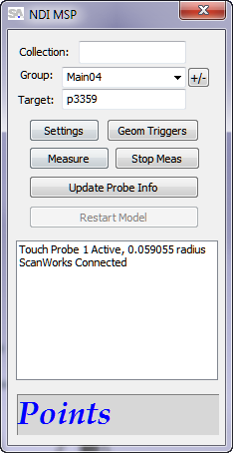
In this case, the attached probe is a 3mm (1.5mm radius) tip, and ScanWorks is successfully communicating with the interface. First, set the Probing Mode in ToolTray. From the Windows Task Bar, right click on the NDI ToolTray icon…
Once again, you’ll get the ToolTray pop-up menu, where you can select the Probing Mode.
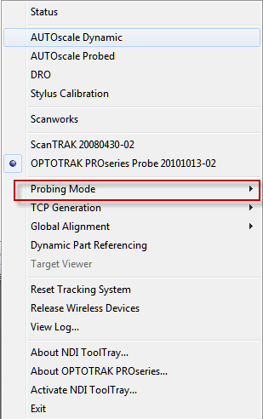
Click the Probing Mode, and you can select “Single” or “Continuous”. In Single mode, each click of the measure button takes a measurement. In Continuous mode, you click the measure button to begin a continuous (time incremented) measurement, and you click it again to pause the acquisition.
The measure buttons on the OptoTrak PROseries Probe are arranged as follows:
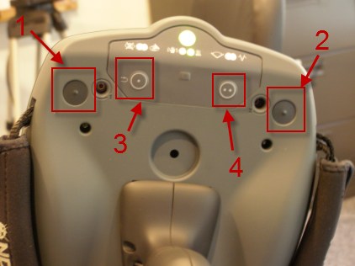
- Measure button (same as the attached trigger button).
- Measure button (same as the attached trigger button).
- Undo button – this will remove the last point from SA.
- Close button – this will disconnect the probe from the SA interface (same as a long button press when using the scanner handle).
NOTE: When you are done using the paddle probe, you can either press button 4, or just go back into the ToolTray pop-up menu and select the ScanTrak. These operations have the exact same effect.
The [Measure] button on the main dialog can of course also be used to take a meausurement. But note that the Perceptron/NDI tcp/ip
interface does not support the Continuous measure mode when commanded from software, only discrete points. The interface does
support the SA MeasurePlan “Measure” and “Stop Active Measurement Mode” commands. The latter is not applicable when the probe
is active however, since only discrete point measurements are supported by Perceptron/NDI when commanded from software. The
interface will return success from the MP “Measure” command when it sends the measurement to SA. However, to support control of
a Continuous measurement, the interface button functions change such that [Measure] becomes a resume, and [Stop Meas] becomes
a pause. In this way, you can begin a Continuous probe measurement from the probe (as required by the sdk), and then pause and
resume that measurement as desired from the interface, until you either change the Probing Mode in ToolTray, change to scanning
in ToolTray, or end the Continuous measurement by pressing the probe’s measure button again to stop the continuous measurement.
Now, select the type of data you want to take in the interface. Just press the [Settings] button, and you will see
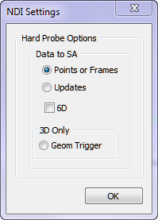
Here, you can send either Points or Updates (e.g. for a watch window) to SA. You can select 6D to send Frames or 6D updates, the latter can be used for TransTrack in SA. You can also use the Geometry Trigger feature. For the Points or Updates data options, you can use either the Single or Continuous Probing Modes in OptoTrak as described above as well as the 6D option. But for the Geom Trigger option, you should use the Continuous Probing Mode, and 6D data is not sent when using the Geom Trigger – only points.
For the Geom Trigger option, select ‘Geom Trigger’ and OK out of the NDI Settings dialog. Then press the [Geom Triggers] button in the interface. You will see the Make Geometry Crossing Triggers window.
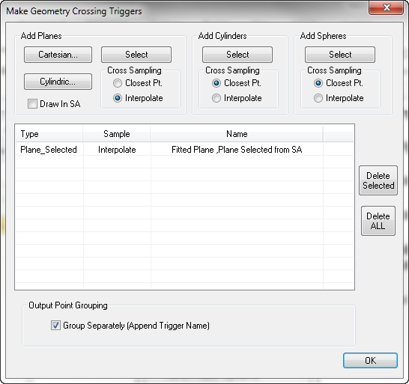
This is the same Geometry Trigger interface that can be found in the SA laser tracker and cmm arm interfaces. Here, a single plane trigger has been defined by selecting it from SA. Here is a pictoral explanation of the Closest Pt. vs. Interpolate sampling methods…
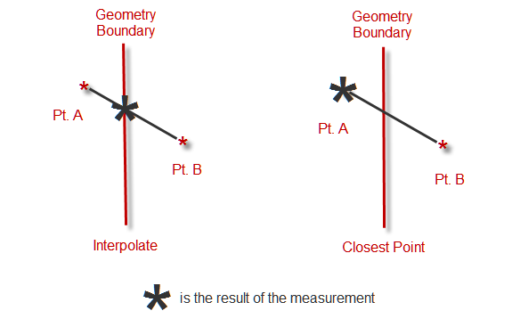
Once you have set up your Geometry Triggers, hit OK and your triggers will be saved until you delete them. NOTE: The triggers are persisted with respect to the NDI camera’s ‘World’ system. So the triggers will move with the camera when you move the camera. For this reason, it is generally recommended that you simply redefine geometry triggers any time your instrument has been moved.
When you are done with probing and wish to use the scanner, either press button 4 (as shown above) on the paddle probe, or just go back into the ToolTray pop-up menu and select the ScanTrak. The interface will report the partial disconnect from ScanWorks as follows.
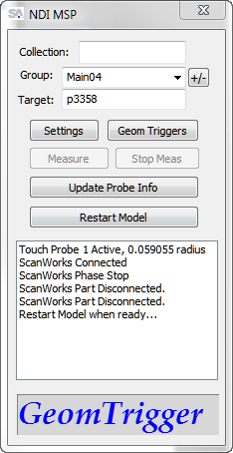
Note also that the [Restart Model] button has now become enabled. At this time, go back into the ToolTray pop-up menu from the ToolTray icon in the Task Bar, and select the ScanTRAK. Once that is done, press the [Restart Model] button in the interface, and you’ll be ready to use the Scanner.

Scanning Mode
Whether you have started the system with the ScanTRAK selected in ToolTray, or followed the connection from Probing as described in the previous section, the interface now shows the ‘Scanner Active’ message, and once again shows ‘ScanWorks Connected’. Now the [Restart Model] button is again disabled since we now have a live connection, and the Measure Mode Setting indicator now Says “Scanner”, since of course only cloud data will be sent when scanning, and the measurement Settings have no effect now.
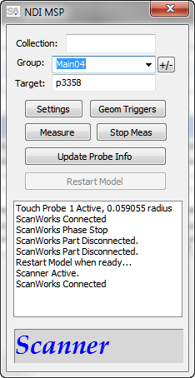
The system is now ready to scan your part by pressing and releasing the button on the scanner handle. A second press of the button will pause the scan. All scanner settings (e.g. rate and density) are made inside ScanWorks. The [Measure] and [Stop Meas] buttons can now be used if desired to stop and start scans. The SA MeasurePlan “Stop Active Measurement Mode” command will also be valid now that the scanner is active, as well as the “Measure” command. In Scanner mode, the MP “Measure” command will return as soon as the scanner has started its measurement.
When you are done using the scanner, you can either press and hold the scanner handle button, or just go back into the ToolTray pop-up menu and select the Probe. These operations have the exact same effect. The interface will report the same partial disconnect from ScanWorks as when we stopped using the probe in the previous section…
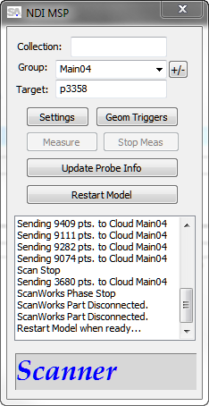
Then if you wish to use the probe, you can once again go into the ToolTray pop-up window by right clicking the ToolTray icon in the Task Bar, and selecting the Probe. Then you’ll once again press the [Restart Model] button to reconnect to ScanWorks in probing mode.
In this way, it is easy to switch back and forth between probing and scanning.

