GSI VSTARS in SpatialAnalyzer

To use the interface, run VSTARS, and add the instrument ‘GSI VSTARS Photogrammetry System’ to SA. It can be found under the Photogrammetry group in the Add Instrument dialog. Upon running the interface, the following will appear.

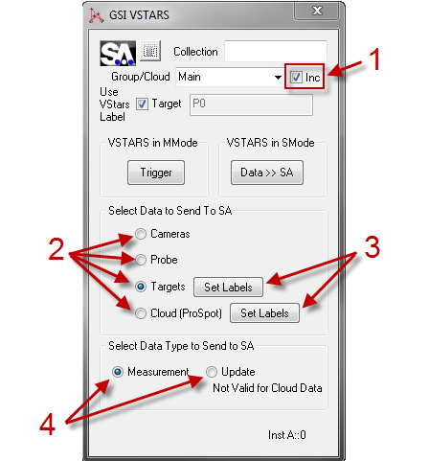

If ‘Use VStars Label’ is checked, then the point labels from VSTARS will be used for all points sent to SA. Otherwise, the name in the edit box (default P0 shown) will be used.
Data is sent to SA in 2 possible ways. If VSTARS is in M-Mode, then selected data is sent any time VSTARS is triggered. This can be done with the ‘Trigger’ shown above, or in VSTARS. The Continuous Trigger option in VSTARS will result in the selected data type being sent to VSTARS upon each trigger event. If VSTARS is in S-Mode, the ‘Data >> SA’ button shown above results in an immediate project import from VSTARS, and selected data is sent to SA.

- Note the Inc check box. This is the Auto-Increment Group (or Cloud) name option. When checked, the group or cloud name will automatically increment after each data send to SA.
- Select Data to Send To SA. These work as follows:
Camera: If VSTARS is in M-Mode, the camera transforms are sent to SA, and all the M-Mode camera positions are shown in SA.
Probe: If VSTARS is in M-Mode, then the most recent PROBE point is sent to SA once a trigger event occurs. Generally, the ‘Inc’ will be unchecked in this case. If VSTARS is in S-Mode, the project is imported immediately, and the most recent PROBE point is sent to SA.
Targets: If VSTARS is in M-Mode, then all selected point types (see 3 below) are sent to SA once a trigger event occurs. Generally, the ‘Inc’ will be checked in this case. If VSTARS is in S-Mode, the project is imported immediately, and all selected points are sent to SA.
Cloud (ProSpot): If VSTARS is in M-Mode, then all selected point types (see 3 below) are sent to SA in the form of a point cloud once a trigger event occurs. Generally, the ‘Inc’ will be checked in this case. Note that the cloud sent will carry then name shown in the ‘Group/Cloud’ edit box. If VSTARS is in S-Mode, the project is imported immediately, and all selected point types are sent to SA in the form of a cloud.
- Set Labels. These are used to set the VSTARS data types (labels) which will be sent when measuring either ‘Targets’ or ‘Cloud (ProSpot)’. The Targets data selection defaults to “CODE”, and the Cloud (ProSpot) data selection defaults to “_S”. The selections denote strings. When any of the selected strings are found in the VSTARS label of a point, that point will be sent to SA in the selected data form (‘Targets’ means points, and ‘Cloud (ProSpot)’ means a point cloud).

Below is shown the Set Labels dialog for ‘Targets’. The dialog is the same for ‘Cloud (ProSpot)’. All types are selected here for readability (un-selected labels are subdued).

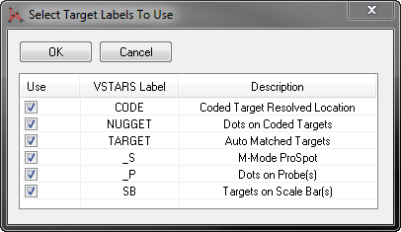
- Select Data Type to Send to SA. By default, the interface sends measurements to SA. Now, you have the option to instead send Updates. Updates are not added to the SA Database like Measurements. Updates are used to update the data in e.g. SA Watch Windows. Updates are meant to be used with Probe data (see section 2), but can be used with all but the Cloud data.

