Peripheral Devices

T-Scan for Leica emScon Trackers
T-Scan systems are delivered complete with an additional controller for the T-Scan, and an application control PC configured to interface with the T-Scan Controller and the LT Controller. SA must be installed on this application control PC in order to run the T-Scan via a COM connection to the T-Scan Collect application. The T-Scan Collect application will normally be pre-installed on the application control PC. For these reasons, the T-Scan interface takes the form of a separate instrument interface in SpatialAnalyzer.
Install SpatialAnalyzer on the T-Scan application control PC, and ensure proper hardware lock operation. Shut down the application control PC. Start the LT Controller, and wait for the ‘happy beep’. Start the application control PC. Once it boots, start the T-Scan controller. *Place the T-Scan in its cradle, and lock the tracker beam on the desired T-Scan mounted reflector by moving the tracker head manually. Start SA and add a Leica emScon tracker as usual. Instead of the Laser Trackers interface, run the Leica T-Scan interface. You’ll see an SA Logon dialog similar to other instruments:
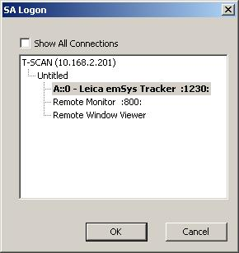
Select the Leica Tracker by double-clicking, or press OK. The T-Scan Collect application will automatically be started, and the main dialog for the SA T-Scan interface will appear.
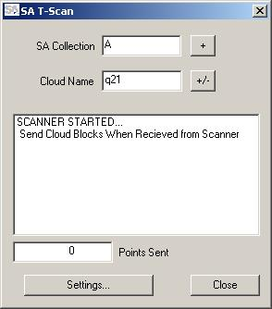
Note the status window shows ‘SCANNER STARTED…’ along with some information regarding user settings on data handling (more on that shortly). If you do not see ‘SCANNER STARTED…’, it is likely that the tracker laser beam is not locked on the T-Scan reflector. Lock the beam on the T-Scan by placing the T-Scan in its nest and manually move the beam on to the desired T-Scan reflector. Then, in the T-Scan Collect application, press the green Start Scanner button (looks like a left-to-right pointing arrow). Note that until the beam is locked on the T-Scan, the Start and Stop buttons in T-Scan Collect are disabled. If you had locked the beam on the T-Scan reflector before starting the SA T-Scan interface, the Start button in T-Scan Collect would be pressed automatically when SA T-Scan made the initial connection.
The ‘SA Collection’ edit box shows the collection in SA where the scan data will be stored. The ‘+’ button next to the ‘SA Collection’ edit box will alpha-numerically increment the collection name. If the edit box is left blank, scan data will be stored in the currently active collection in SA. The ‘Cloud Name’ edit box shows the point cloud into which the next acquired data will be stored in SA. Left clicking the ‘+/-‘ button will numerically increment the name, and right clicking will decrement it. The large text box shows current status and actions performed by the interface, and the ‘Points Sent’ text box shows the number of cloud points sent to SA since the interface was started.
To take data, simply use the laser line/location dot on the T-Scan to keep the proper distance from the scanned surface, and press the trigger button on the T-Scan. During a typical measurement, the dialog will appear as follows:
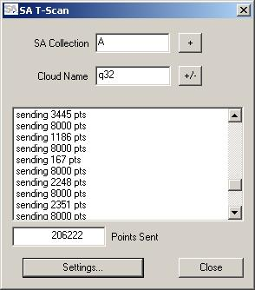
The status window updates with each cloud packet sent to SA, reporting the size of the packet in points. The status will ‘roll’, showing the latest information at the bottom of the status window. After a large number of status lines is displayed, the status window will clear itself. At the end of a scan, the status dialog will show some stats with total scan lines and number of points sent during that scan.
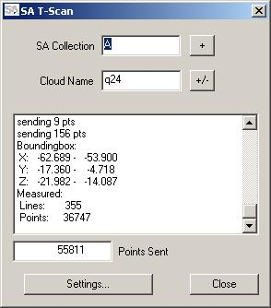
Data sampling and naming options can be set by pressing the ‘Settings..’ button. The connection to T-Scan Collect will be temporarily severed, and the Data Handling dialog will appear, showing the options which can be edited:
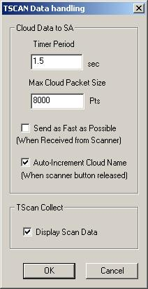
The interface will send a cloud packet to SA at the interval set by the ‘Timer Period’. If the cloud points in a buffered packet reach the ‘Max Cloud Packet Size’ before the ‘Timer Period’ has expired, the cloud will be sent immediately. (The main T-Scan interface window shown above during a scan was captured during a scan using the settings shown here.) When checked, ‘Auto-Increment Cloud Name’ will increment the cloud name after each packet is sent to SA. If ‘Display Scan Data’ under the ‘TScan Collect’ settings is checked, then scan data will be displayed in T-Scan Collect. NOTE: It is recommended that you un-check this option to reduce taxing the application control PC and its video card.
If ‘Send as Fast as Possible’ is checked, the interface will not buffer data from T-Scan Collect. It will send data packets as they are received from T-Scan Collect. With this option checked, the timer period and max cloud size are not used, and are therefore disabled as shown below.
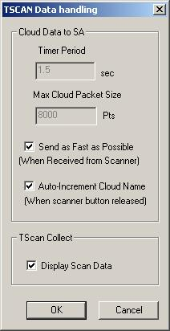
When all options are set as desired, press OK. The connection to T-Scan Collect will be re-established, and the main dialog will again report ‘SCANNER STARTED…’ along with some information regarding the settings. Continue scanning by simply pressing and releasing the T-Scan trigger to begin and end scans.
When scanning is complete, close the SA T-Scan interface. Also move the T-Scan to a position such that the T-CAM will not be able to ‘see’ the T-Scan LED’s. The T-Scan Collect application will automatically be closed (unless it was already running when the SA T-Scan interface was started. In that case, just close it manually.)
It will now be common to run the SA Laser Tracker interface, and connect to the same tracker in SA which was just run with the T-Scan interface. This will be in order to measure common location positions (with SMR, T-Probe, etc.) in order to move the tracker to a new location. Then, a new tracker will be added to SA, and both the SA Laser Tracker interface and the SA T-Scan interface can be run from that new tracker location. Both interfaces can be run connecting to any emScon tracker model/location in SA for any number of times, and in any order.

